**EMBARGOED until 4am EST (9am BST) on 9th August 2024**

**Room-Filling Sound, Timeless Design:  
Cambridge Audio Evo One wireless streaming speaker**

* *14 perfectly tuned drivers powered by 700W of amplification for room-filling, wide-dispersion sound*
* *StreamMagic Gen 4 technology offers award-winning wireless streaming direct from Spotify Connect, TIDAL Connect, Deezer, Qobuz, Roon Ready and Internet Radio*
* *AirPlay 2, Bluetooth and Google Cast*
* *Wired connectivity with HDMI eARC, optical digital input, aux in, Ethernet, USB, and an MM phono stage for directly hooking up a turntable*
* *Advanced Digital Signal Processing with a 7-band EQ and room-optimisation settings to hone the sound for every taste and space*
* *Large 6.8” colour screen with choice of VU meters, album artwork or clock display*
* *Compatible with Google Home, Apple AirPlay and Roon multiroom systems​*
* *Beautifully designed, engineered and acoustically optimised at Cambridge Audio’s own London-based music venue and HQ, Melomania*

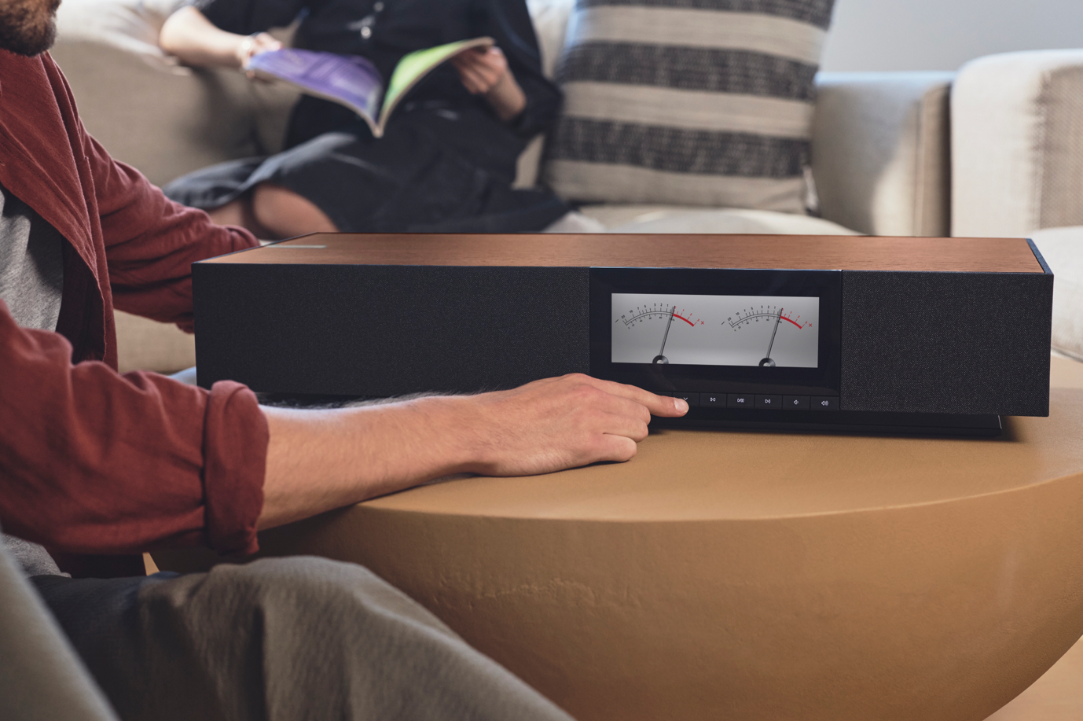

***9th August 2024:*** British music and audio pioneer, **Cambridge Audio**, is excited to launch **Evo One**, a breathtakingly powerful, stylish wireless speaker that offers unrivalled performance, connectivity and versatility.

For the first time, you can fill your space with Cambridge’s signature sound from just one product, impeccably designed by Red Dot Award-winning designer Ged Martin.

Taking the hi-res streaming smarts and musicality of the Evo 75 and Evo 150 streaming amplifiers, Evo One channels that acclaimed performance through 14 perfectly tuned drivers and 700W of amplification to create a unique omni-directional audio experience.

Evo One’s streaming prowess, allowing users to listen easily via almost any music service, is powered by Cambridge’s StreamMagic platform, which also lies at the heart of its award-winning network players including CXN100 and MXN10.

“Our aim was to distil our decades of expertise in sound and streaming into a user-friendly, one-box experience. Evo One achieves all that and so much more. Aesthetically as well as sonically and functionally, it truly enriches every space and occasion,” says Matt Dore, Chief Technical Officer of Cambridge Audio.

The perfect all-in-one audio solution, Evo One is a fuss-free and beautiful way to enjoy your favourite music, movies and more.

**ROOM-FILLING SOUND**

An array of 14 drivers – 4 x 1" silk dome tweeters, 4 x 2.25" aluminium cone mid-range, and 6 x 2.75" long-throw woofers – surround the Evo One in front-, side- and rear-firing configurations to deliver a phenomenally wide sound dispersion and a truly expansive soundstage. There’s no need to sit in a sonic ‘sweetspot’ as you would with most wireless speakers – with Evo One, every seat in the room is treated to glorious sound.

Power is delivered by 700W of Class D amplification – 50W (RMS) per driver for fine control – while an advanced Digital Signal Processing (DSP) has allowed for perfect tuning of the Cambridge signature sound. The result is breathtaking clarity and deep controlled bass that defies the limits of the one-box form factor.

Within the StreamMagic control app, audio can be personalised to the listener’s taste. A seven-band EQ can be used to tweak the sonics manually to an astoundingly precise degree, while a wealth of presets is offered tailored to multiple music genres and TV-watching scenarios. Room-optimisation features in the app enable you to adapt the sound manually to your unique living space.

As with all Cambridge products, Evo One has been designed, tuned and engineered at our own London music venue and HQ, Melomania, by the same passionate team behind our award-winning hi-fi equipment.

**EVERY LISTENING BASE COVERED**

Evo One is built around the 4th generation of StreamMagic, Cambridge Audio’s industry-leading streaming platform for seamless, stable listening across an enormous number of services and formats.

StreamMagic enables direct streaming from Spotify Connect, TIDAL Connect, Deezer, Qobuz, Roon Ready, UPnP and Internet Radio with support up to 32-bit/192kHz hi-res audio over Wi-Fi or Ethernet. As Cambridge owns and develops the StreamMagic platform itself, new features and services are regularly added to improve and increase its functionality.

For maximum wireless flexibility, Evo One gives the options of Bluetooth, AirPlay 2 and Google Cast. To share music across devices all around the home, Evo One is fully compatible with Google Home, Apple AirPlay and Roon multiroom systems​.

Wired connectivity is equally well served. HDMI eARC means the Evo One can be connected to a TV, forming the sound foundations of your home entertainment system. A moving-magnet (MM) phono stage means a hi-fi turntable can be directly connected, while a line input takes care of other analogue sources. An optical digital input and USB-A media socket provide further digital options.

While all of Evo One’s functionality can be accessed via the StreamMagic app, and the HDMI eARC connection enables simple volume control through a TV remote, a dedicated remote control is supplied to ensure complete ease of use for anyone in the room.

Every base is covered.

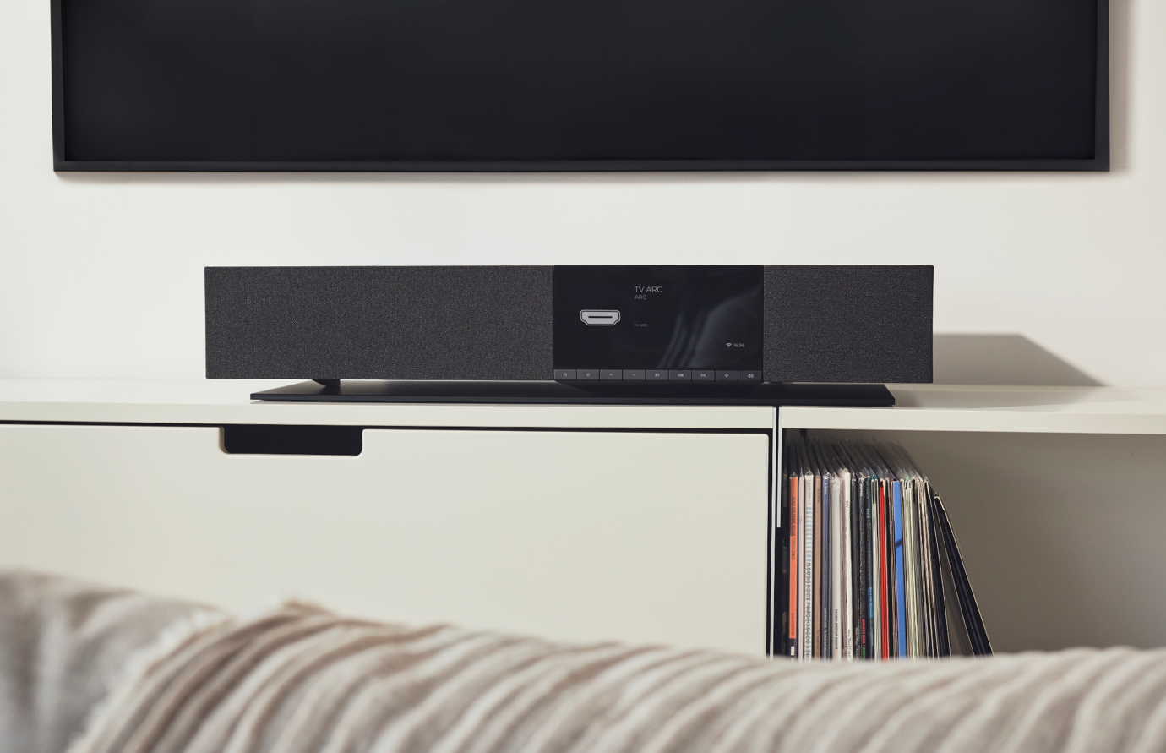

**ENVIABLE DESIGN**

Evo One is more than just incredible sound; it’s a visual treat, a stylish addition to any home. The minimalist retro-modern aesthetic, designed in London by Red Dot Award-winning designer Ged Martin, is both fresh and yet undeniably part of the Evo family.

Clean lines, a timeless feel, and an undeniable air of luxury. Thanks to a beautifully figured real walnut veneer, the top of every Evo One is unique.

The innovative grille construction Inspired by natural honeycomb forms, protecting the drivers while placing less mass in front of them to avoid obstructing the sound. This structure is then covered with acoustically transparent fabric that allows music to fill the room unimpeded.

Continuing Evo One’s theme of unparallelled versatility, the large 6.8” colour screen offers the choice of pure function or a taste of retro-chic style. Cycle through a clock display, the album artwork and info of the current track, or else enjoy the mesmerising tick of virtual VU meters.

Evo One also builds on Cambridge’s aims for increased sustainability, with any plastic parts including a minimum of 50% recycled material, an FSC-certified wood veneer cabinet and optimised power consumption.

This drive to create a more sustainable product builds on Cambridge’s support as Founding Donor of the eco-music charity EarthPercent, which was co-founded by the iconic Brian Eno.   
  
**Cambridge Audio Evo One is available at cambridgeaudio.com and approved retailers, priced at £1299/€1499/$1499.** **Hi-res images can be downloaded from** [**here**](https://audiopart-my.sharepoint.com/:f:/g/personal/zdrive-marketing-assets_audiopartnership_com/EojR0AfCA1JPqq6ntvxl-uoBgwSFA9MQ5-bBVW20PyDFzg?e=GKWzv0)

**KEY FEATURES**

* 14 drivers (4 x 1" silk dome tweeters, 4 x 2.25" aluminium cone mid-range, and 6 x 2.75" long-throw woofers)
* 700W Class D amplification (50W RMS per driver)
* Large 6.8” 1280 x 480 IPS TFT colour screen with choice of VU meters, album artwork or clock display
* StreamMagic Gen 4 module supporting TIDAL Connect, Spotify Connect, Qobuz, Deezer, Roon Ready, UPnP and Internet Radio
* FSC-certified wood veneer and MDF cabinet with beautifully figured natural walnut top
* Supported audio formats: WAV, FLAC, ALAC, AIFF, DSD (DSF and DFF), WMA, MP3 (CBR and VBR), AAC, HE AAC and AAC+ (CBR and VBR), OGG Vorbis
* Support for up to 32-bit/192kHz audio resolution
* 7-band EQ adjustment with custom EQ save option, plus a range of EQ presets
* Room-optimisation settings to tune the sound to your room and placement
* Wireless connectivity: Wi-Fi, Bluetooth 5.1 A2DP, AirPlay 2, Google Cast
* Wired connectivity: HDMI eARC, Ethernet, RCA line in, MM phono, digital optical, USB-A Media
* Supplied remote control
* 675 x 129 x 290mm (26.6 x 5.1 x 11.4"), 14.5kg (32lbs)

**About Cambridge Audio**

Based in the heart of London, Cambridge Audio has pursued one simple objective since its inception in 1968: to connect people to the power of music. Everything it does is Made By Music.

From the iconic P40 amplifier of the ’60s to the award-winning Evo all-in-one music system and globally acclaimed Melomania true wireless earphones, Cambridge Audio designs each product from the ground up to deliver that emotional hit from your favourite music. It’s what you as a listener deserve.

Their award-winning product portfolio spans headphones, through to lifestyle and premium audio systems and components.

Cambridge Audio also launched its Made By Music podcast in 2023. Iconic artists such as Boy George, Fatboy Slim and Matt Berry highlight the songs they are most proud of, and share the biggest musical influences in their careers – each episode an unashamed love letter to music.

Visit: [www.cambridgeaudio.com](http://www.cambridgeaudio.com)

**Contact**

For press enquiries please contact:

**Simon Osborne-Walker**  
+44 7956 926 832  
[**simon.osborne-walker@cambridgeaudio.com**](mailto:simon.osborne-walker@cambridgeaudio.com)